

Robotics

Robotics is the intersection of science, engineering and technology that produces machines, called robots, that substitute for (or replicate) human actions. Pop culture has always been fascinated with robots. R2-D2. Optimus Prime. WALL-E. These over-exaggerated, humanoid concepts of robots usually seem like a caricature of the real thing...or are they more forward thinking than we realize? Robots are gaining intellectual and mechanical capabilities that don’t put the possibility of a R2-D2-like machine out of reach in the future



**Early Conceptions of Robots**

One of the first instances of a mechanical device built to regularly carry out a particular physical task occurred around 3000 B.C.: Egyptian water clocks used human figurines to strike the hour bells. In 400 B.C., Archytus of Taremtum, inventor of the pulley and the screw, also invented a wooden pigeon that could fly. Hydraulically-operated statues that could speak, gesture, and prophecy were commonly constructed in Hellenic Egypt during the second century B.C.

In the first century A.D., Petronius Arbiter made a doll that could move like a human being. Giovanni Torriani created a wooden robot that could fetch the Emperor's daily bread from the store in 1557. Robotic inventions reached a relative peak (before the 20th century) in the 1700s; countless ingenius, yet impractical, automata (i.e. robots) were created during this time period. The 19th century was also filled with new robotic creations, such as a talking doll by Edison and a steam-powered robot by Canadians. Although these inventions throughout history may have planted the first seeds of inspiration for the modern robot, the scientific progress made in the 20th century in the field of robotics surpass previous advancements a thousandfold.

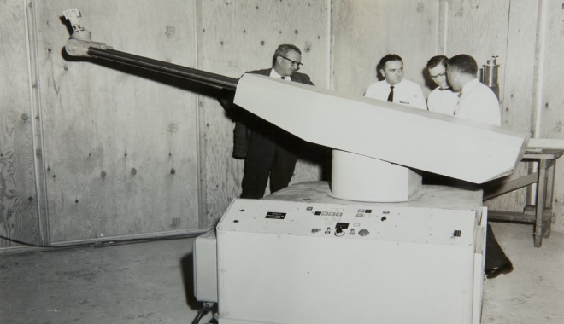

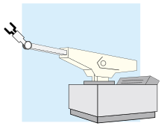

Unimate

Unimate was the first industrial robot, which worked on a General Motors assembly line at the Inland Fisher Guide Plant in Ewing Township, New Jersey, in 1961. It was invented by **George Devol** in the 1950s using his original patent filed in 1954 and granted in 1961 (U.S. Patent 2,988,237).



**The first modern robots**

The earliest robots as we know them were created in the early 1950s by George C. Devol, an inventor from Louisville, Kentucky.  He invented and patented a reprogrammable manipulator called "Unimate," from "Universal Automation."  For the next decade, he attempted to sell his product in the industry, but did not succeed.  In the late 1960s, businessman/engineer Joseph Engleberger acquired Devol's robot patent and was able to modify it into an industrial robot and form a company called Unimation to produce and market the robots.  For his efforts and successes, Engleberger is known in the industry as "the Father of Robotics."  
        Academia also made much progress in the creation new robots.  In 1958 at the Stanford Research Institute, Charles Rosen led a research team in developing a robot called "Shakey."  Shakey was far more advanced than the original Unimate, which was designed for specialized, industrial applications.  Shakey could wheel around the room, observe the scene with his television "eyes," move across unfamiliar surroundings, and to a certain degree, respond to his environment.  He was given his name because of his wobbly and clattering movements.

